Weitere Kooperationen China

1.

高鹏 博士 Dr. Peng Gao (CEO)

CHINA WINDOW International Information Technology Joint-Venture Company GERMANY
Tel: +49 6106 776 787 Mobile: +49 170 3085 880
广州凯勒德中信息科技有限公司 CHINA
Tel：+86 20 8550 7716 Mobile: +86 139 2886 1978
E-mail: drgp@chinawindow-keller.com
www.chinawindow-keller.com

2.
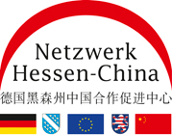

3.
Dongguan Polytechnik Hochschule
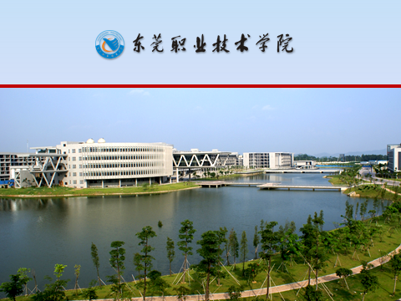
4. Dalian 2005

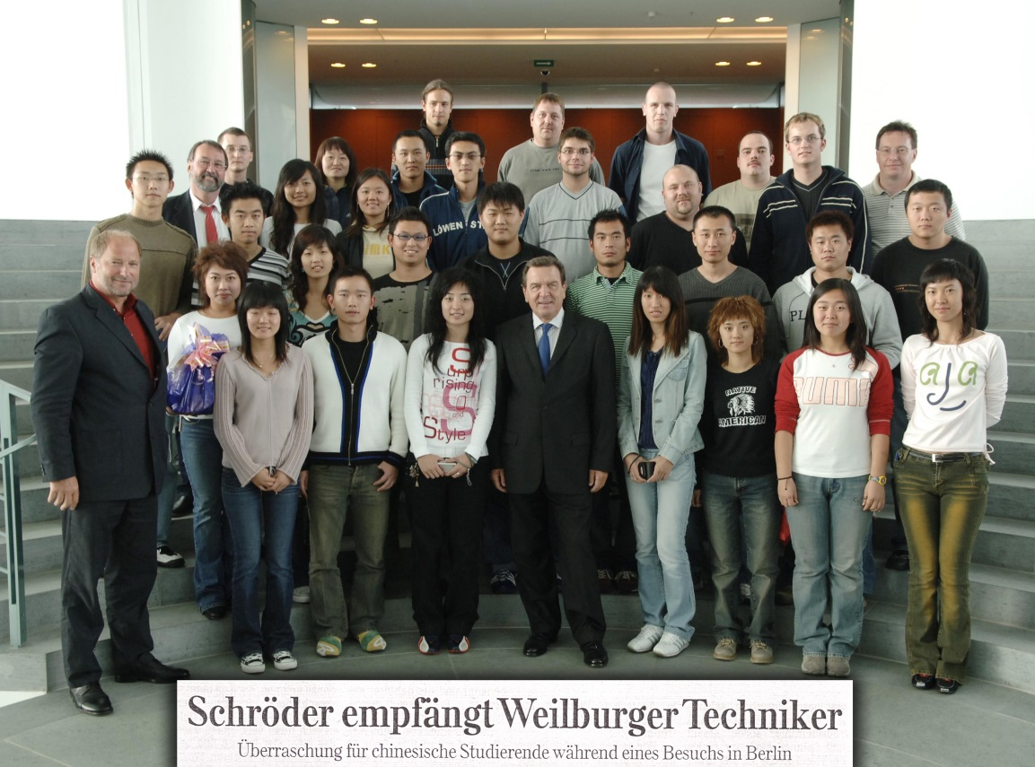

5. Suzhou 2009

